DBMS Assignment 01

Submitted By : Subrat Kumar Nanda

ER Diagram-

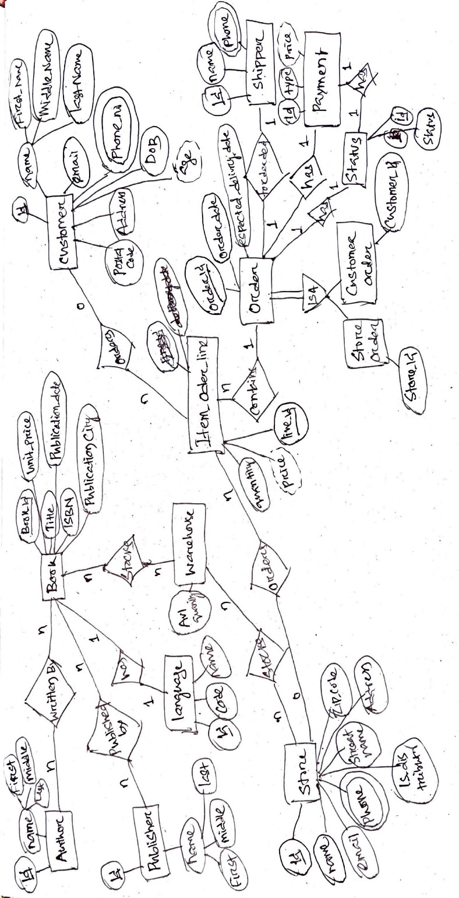

Data Model : Diagram

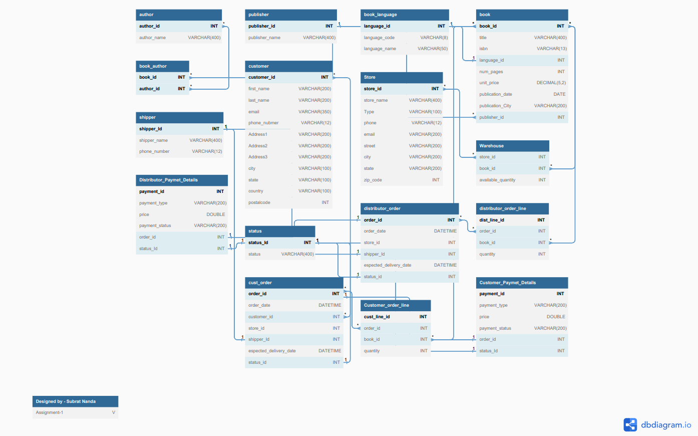



Store Procedure:

sp_GetBooks – input storeid , bookid & quantity.

Description: To place an order for store when running out of Book Stock. This will be placing an order for the Store, generating the payment and delivery details, and updating the warehouse with the book quantity.

O/P – Display

Distributor_Order,

Distributor_Order_Details,

Distributor_Payment_Details &

Book_Available_Details.

Test :

Current Available Status of Book_ID = 1 in Store_id = 4 is 0.

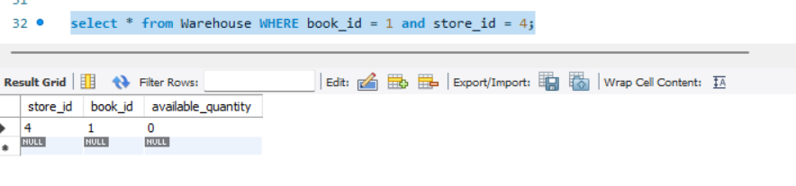

The store wanted to place an order of 10 book.

Distributor_Order:

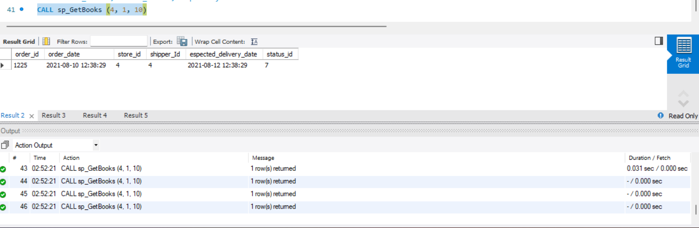

Distributor_Order_Details

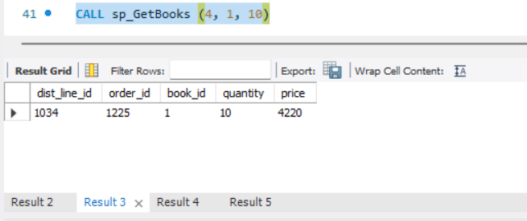

Payment_Details:

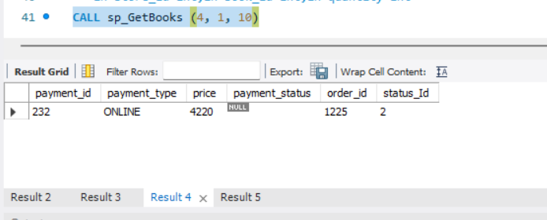

Updated_Book_Available_Details:

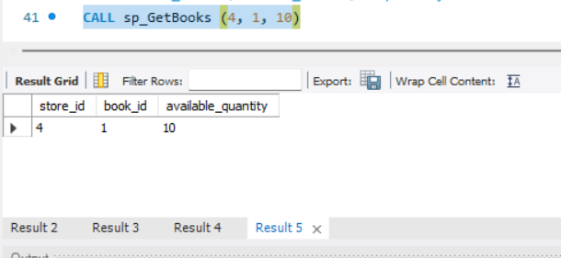

**Trigger:**

before_is_available : -> BEFORE INSERT ON Customer_order_line

Desc: To check the user-requested book quantity. If the appropriate quantity is unavailable, it will restrict the entry of the record to the table and show an appropriate error message.

**Condition 1:** When requested quantity <=0 : Display Error: “PLEASE ENTER A VALID BOOK QUANTITY”

**Condition 2:** When requested quantity > Available Quantity: Display Error: “NOT AVAILABLE - ORDER QUANTITY EXCEEDS AVAILABLE QUANTITY - AVAILABLE_BOOK_QTY = #{No of Quantity Available}”

**Condition 3:** When requested quantity < Available Quantity:

The record will be inserted into the Table and also Book Availability will be updated as Book_Quantity – Ordered_Book_Quantity

Test:

Currently Book Availability

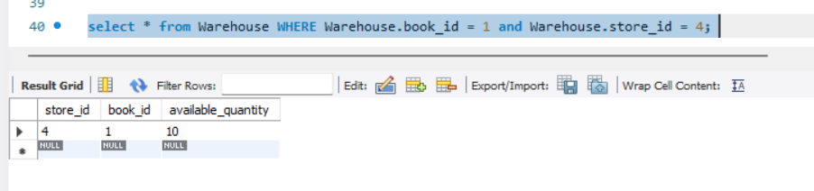

Condition 1 : requesting invalid quantity or 0 Quantity

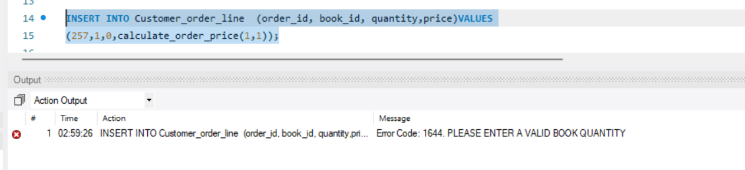

Condition 2 : requested quantity > Available Quantity

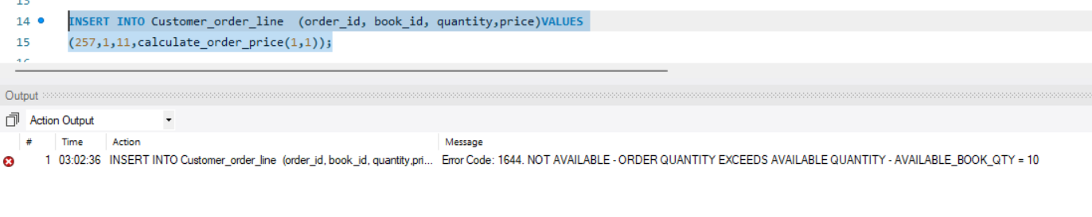

Condition 3: When requested quantity < Available Quantity:

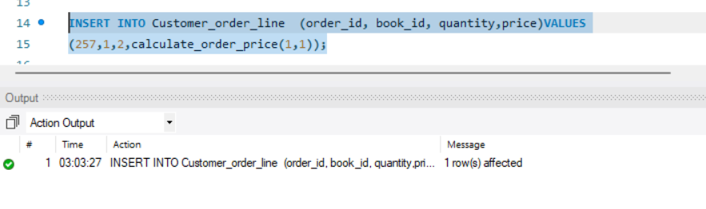

Order_Details

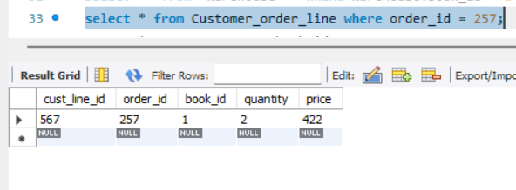

Also Checking Current Book_Availability :

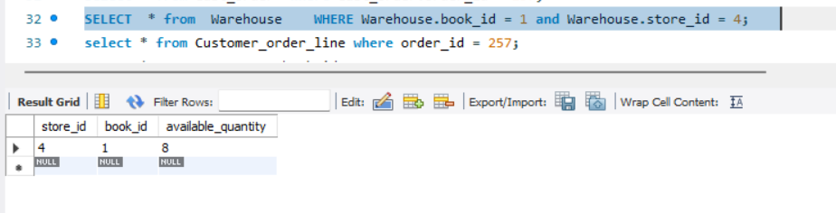

before_genrate_book_unit_price : -> BEFORE INSERT ON book : To Generate a random Book Price when entered as empty or less than 0.

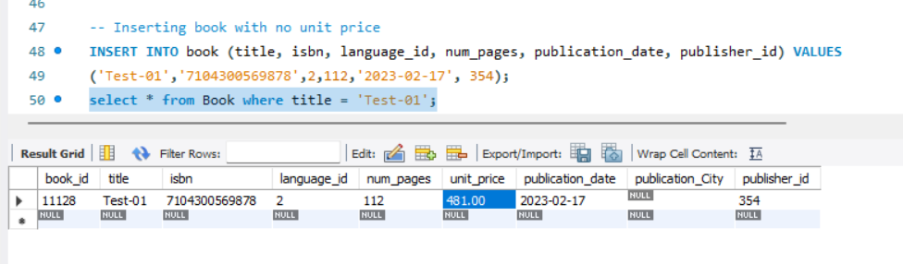

**Function** :

calculate_order_price : Calculate the Amount

input Param - book_id & quantity

output/Return - order_value = Book_Price * Quantity

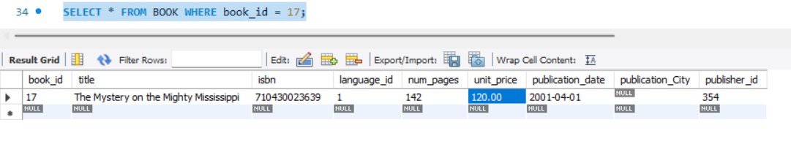

Calculating 5 Book price :

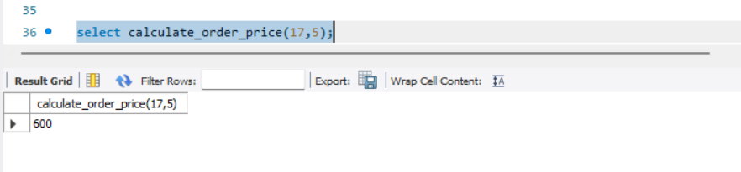

Fetching Below Query Results:

Q6: Write PYTHON codes that connects to this database and use SQL commands to select and

retrieve information about availability of books identified by title, author, publisher or year

of publication

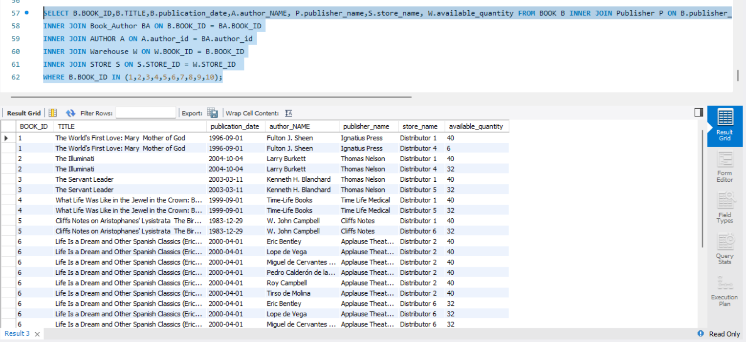

**MySQL with Python (Jupyter NoteBook)**

MySQL Connector Installation for Anaconda :

GoTo Anaconda Command Prompt : Enter Below Command

conda install -c conda-forge mysql-connector-python

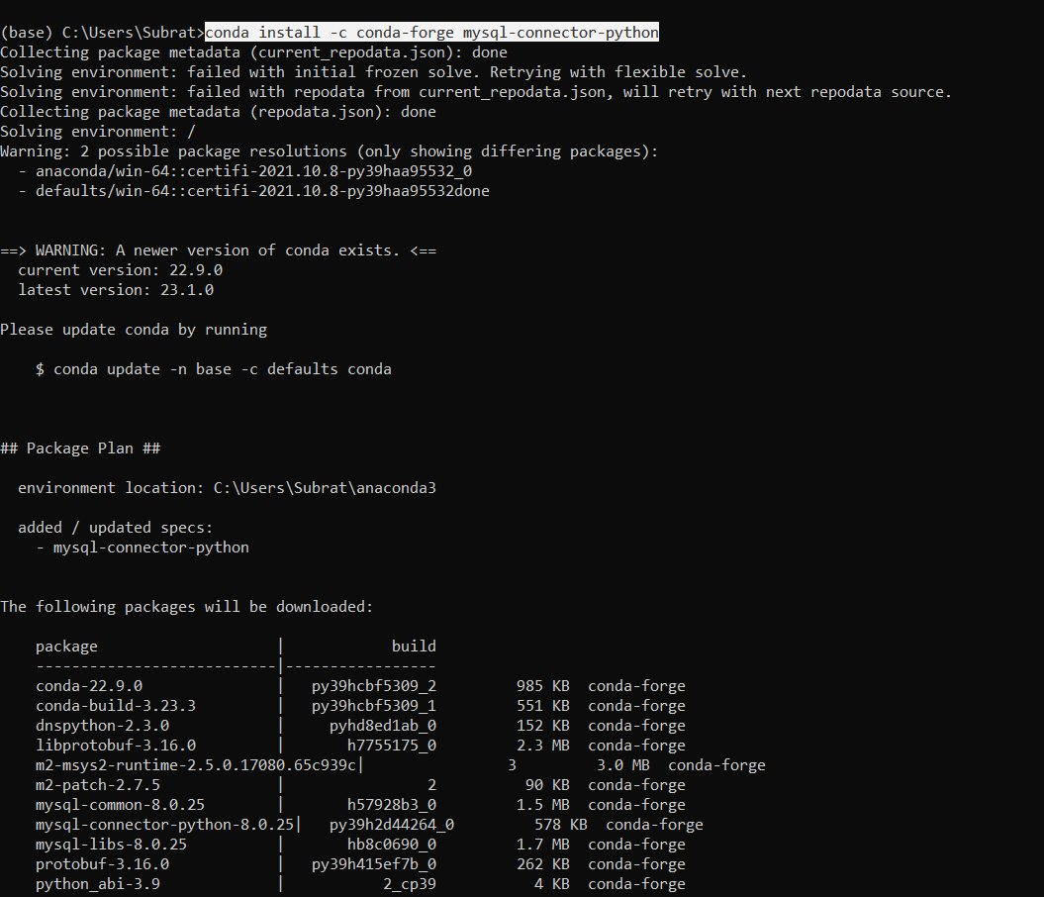

Connection :

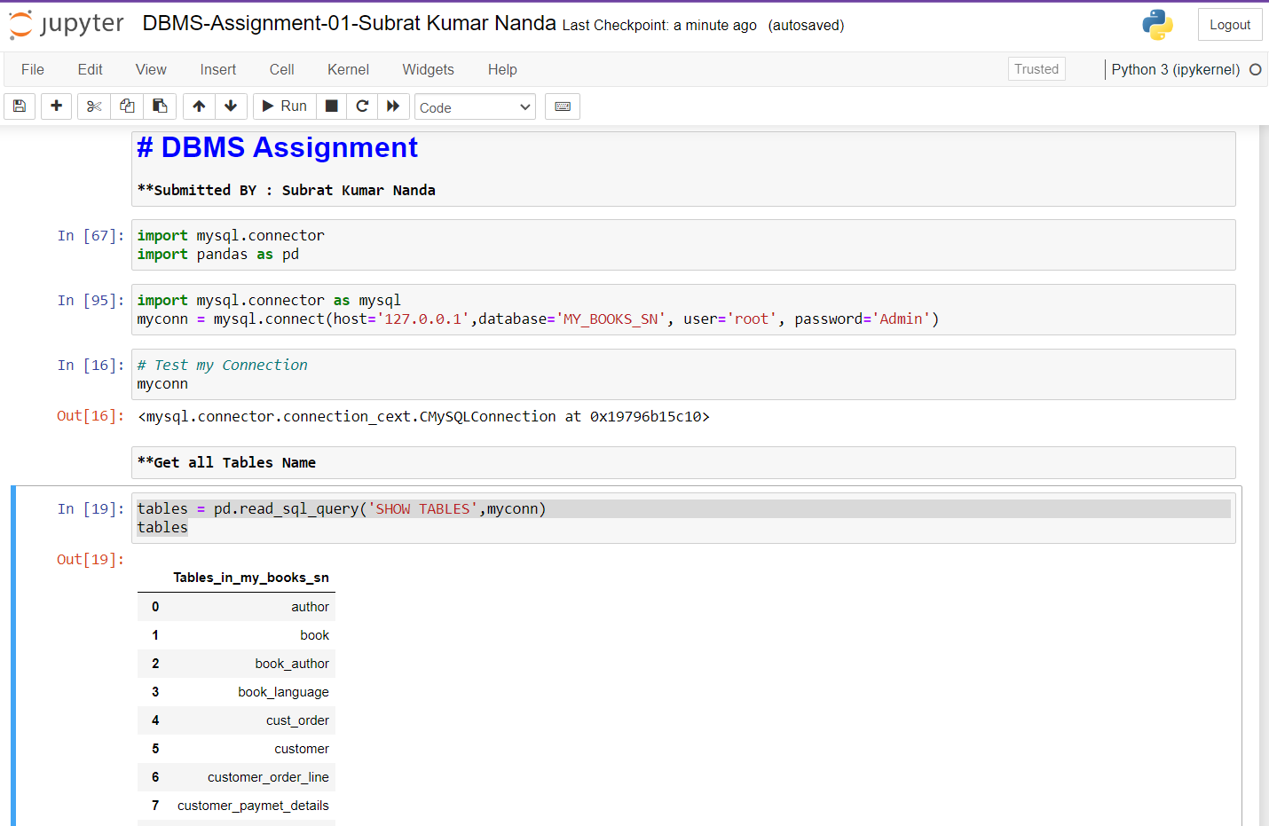

Query Results:

